Personal Loan Decision Tree

Here we have used first Random Forest Classifier and know its important features afterwards we will know its important features and then we will use Random Forest.

Image of Decision Tree

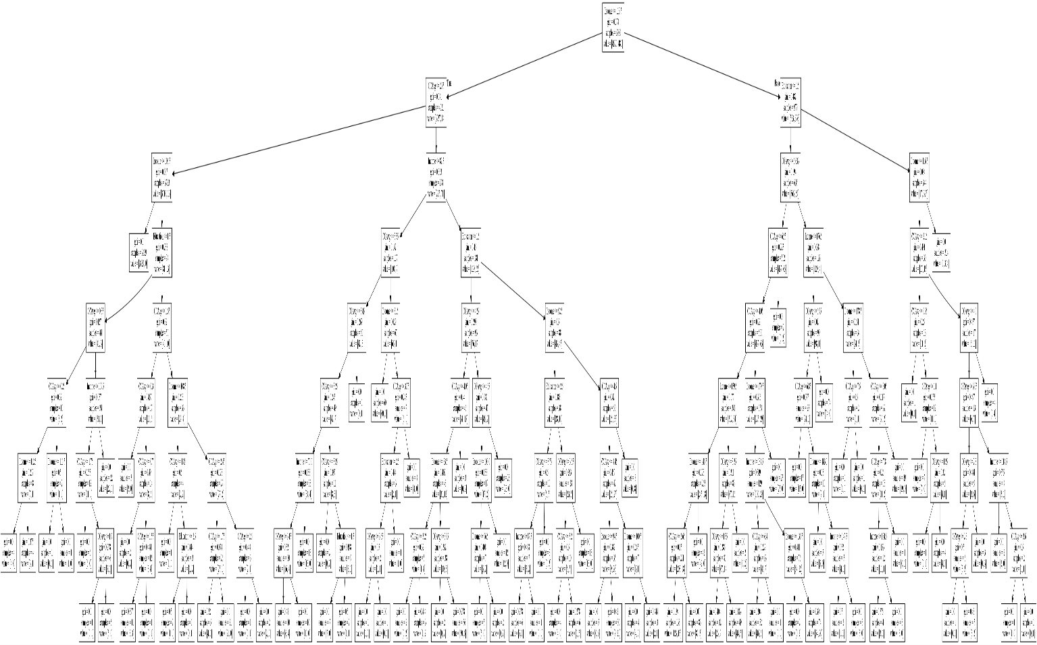

Pseudo Rule of Personal Rule

|--- Income <= 113.50

| |--- CCAvg <= 2.95

| | |--- Income <= 106.50

| | | |--- class: 0

| | |--- Income > 106.50

| | | |--- Education <= 1.50

| | | | |--- CCAvg <= 0.35

| | | | | |--- CCAvg <= 0.25

| | | | | | |--- Income <= 112.50

| | | | | | | |--- class: 0

| | | | | | |--- Income > 112.50

| | | | | | | |--- class: 0

| | | | | |--- CCAvg > 0.25

| | | | | | |--- Income <= 111.50

| | | | | | | |--- class: 1

| | | | | | |--- Income > 111.50

| | | | | | | |--- class: 0

| | | | |--- CCAvg > 0.35

| | | | | |--- Income <= 109.50

| | | | | | |--- CCAvg <= 1.75

| | | | | | | |--- class: 0

| | | | | | |--- CCAvg > 1.75

| | | | | | | |--- CCAvg <= 1.90

| | | | | | | | |--- class: 1

| | | | | | | |--- CCAvg > 1.90

| | | | | | | | |--- class: 0

| | | | | |--- Income > 109.50

| | | | | | |--- class: 0

| | | |--- Education > 1.50

| | | | |--- CCAvg <= 1.65

| | | | | |--- CCAvg <= 0.30

| | | | | | |--- class: 0

| | | | | |--- CCAvg > 0.30

| | | | | | |--- CCAvg <= 0.70

| | | | | | | |--- class: 1

| | | | | | |--- CCAvg > 0.70

| | | | | | | |--- CCAvg <= 1.55

| | | | | | | | |--- class: 0

| | | | | | | |--- CCAvg > 1.55

| | | | | | | | |--- class: 1

| | | | |--- CCAvg > 1.65

| | | | | |--- Income <= 108.50

| | | | | | |--- CCAvg <= 1.85

| | | | | | | |--- class: 0

| | | | | | |--- CCAvg > 1.85

| | | | | | | |--- Education <= 2.50

| | | | | | | | |--- class: 0

| | | | | | | |--- Education > 2.50

| | | | | | | | |--- class: 1

| | | | | |--- Income > 108.50

| | | | | | |--- CCAvg <= 2.45

| | | | | | | |--- CCAvg <= 1.75

| | | | | | | | |--- class: 0

| | | | | | | |--- CCAvg > 1.75

| | | | | | | | |--- class: 0

| | | | | | |--- CCAvg > 2.45

| | | | | | | |--- CCAvg <= 2.60

| | | | | | | | |--- class: 1

| | | | | | | |--- CCAvg > 2.60

| | | | | | | | |--- class: 0

| |--- CCAvg > 2.95

| | |--- Income <= 82.50

| | | |--- CCAvg <= 3.55

| | | | |--- CCAvg <= 3.45

| | | | | |--- CCAvg <= 3.25

| | | | | | |--- Income <= 70.00

| | | | | | | |--- CCAvg <= 3.15

| | | | | | | | |--- class: 0

| | | | | | | |--- CCAvg > 3.15

| | | | | | | | |--- class: 0

| | | | | | |--- Income > 70.00

| | | | | | | |--- class: 0

| | | | | |--- CCAvg > 3.25

| | | | | | |--- CCAvg <= 3.35

| | | | | | | |--- class: 1

| | | | | | |--- CCAvg > 3.35

| | | | | | | |--- Education <= 1.50

| | | | | | | | |--- class: 0

| | | | | | | |--- Education > 1.50

| | | | | | | | |--- class: 0

| | | | |--- CCAvg > 3.45

| | | | | |--- class: 1

| | | |--- CCAvg > 3.55

| | | | |--- Income <= 81.50

| | | | | |--- class: 0

| | | | |--- Income > 81.50

| | | | | |--- CCAvg <= 3.75

| | | | | | |--- Education <= 2.50

| | | | | | | |--- CCAvg <= 3.65

| | | | | | | | |--- class: 0

| | | | | | | |--- CCAvg > 3.65

| | | | | | | | |--- class: 1

| | | | | | |--- Education > 2.50

| | | | | | | |--- class: 0

| | | | | |--- CCAvg > 3.75

| | | | | | |--- class: 0

| | |--- Income > 82.50

| | | |--- Education <= 1.50

| | | | |--- CCAvg <= 4.25

| | | | | |--- CCAvg <= 4.05

| | | | | | |--- Income <= 83.50

| | | | | | | |--- CCAvg <= 3.25

| | | | | | | | |--- class: 1

| | | | | | | |--- CCAvg > 3.25

| | | | | | | | |--- class: 1

| | | | | | |--- Income > 83.50

| | | | | | | |--- CCAvg <= 3.05

| | | | | | | | |--- class: 1

| | | | | | | |--- CCAvg > 3.05

| | | | | | | | |--- class: 0

| | | | | |--- CCAvg > 4.05

| | | | | | |--- class: 1

| | | | |--- CCAvg > 4.25

| | | | | |--- CCAvg <= 4.65

| | | | | | |--- Income <= 100.00

| | | | | | | |--- Income <= 96.50

| | | | | | | | |--- class: 0

| | | | | | | |--- Income > 96.50

| | | | | | | | |--- class: 1

| | | | | | |--- Income > 100.00

| | | | | | | |--- class: 0

| | | | | |--- CCAvg > 4.65

| | | | | | |--- class: 0

| | | |--- Education > 1.50

| | | | |--- Income <= 92.50

| | | | | |--- Education <= 2.50

| | | | | | |--- CCAvg <= 3.75

| | | | | | | |--- Income <= 87.50

| | | | | | | | |--- class: 0

| | | | | | | |--- Income > 87.50

| | | | | | | | |--- class: 1

| | | | | | |--- CCAvg > 3.75

| | | | | | | |--- class: 1

| | | | | |--- Education > 2.50

| | | | | | |--- CCAvg <= 3.65

| | | | | | | |--- CCAvg <= 3.20

| | | | | | | | |--- class: 0

| | | | | | | |--- CCAvg > 3.20

| | | | | | | | |--- class: 1

| | | | | | |--- CCAvg > 3.65

| | | | | | | |--- class: 0

| | | | |--- Income > 92.50

| | | | | |--- CCAvg <= 4.60

| | | | | | |--- CCAvg <= 4.45

| | | | | | | |--- Income <= 94.50

| | | | | | | | |--- class: 1

| | | | | | | |--- Income > 94.50

| | | | | | | | |--- class: 1

| | | | | | |--- CCAvg > 4.45

| | | | | | | |--- Income <= 100.50

| | | | | | | | |--- class: 0

| | | | | | | |--- Income > 100.50

| | | | | | | | |--- class: 0

| | | | | |--- CCAvg > 4.60

| | | | | | |--- class: 1

|--- Income > 113.50

| |--- Education <= 1.50

| | |--- CCAvg <= 6.63

| | | |--- CCAvg <= 6.55

| | | | |--- CCAvg <= 4.05

| | | | | |--- Income <= 159.50

| | | | | | |--- Income <= 146.50

| | | | | | | |--- CCAvg <= 2.65

| | | | | | | | |--- class: 0

| | | | | | | |--- CCAvg > 2.65

| | | | | | | | |--- class: 0

| | | | | | |--- Income > 146.50

| | | | | | | |--- class: 0

| | | | | |--- Income > 159.50

| | | | | | |--- CCAvg <= 3.35

| | | | | | | |--- CCAvg <= 1.55

| | | | | | | | |--- class: 0

| | | | | | | |--- CCAvg > 1.55

| | | | | | | | |--- class: 0

| | | | | | |--- CCAvg > 3.35

| | | | | | | |--- class: 1

| | | | |--- CCAvg > 4.05

| | | | | |--- Income <= 179.50

| | | | | | |--- Income <= 134.50

| | | | | | | |--- CCAvg <= 6.40

| | | | | | | | |--- class: 0

| | | | | | | |--- CCAvg > 6.40

| | | | | | | | |--- class: 1

| | | | | | |--- Income > 134.50

| | | | | | | |--- Income <= 136.50

| | | | | | | | |--- class: 1

| | | | | | | |--- Income > 136.50

| | | | | | | | |--- class: 0

| | | | | |--- Income > 179.50

| | | | | | |--- class: 0

| | | |--- CCAvg > 6.55

| | | | |--- class: 1

| | |--- CCAvg > 6.63

| | | |--- Income <= 176.50

| | | | |--- CCAvg <= 6.95

| | | | | |--- CCAvg <= 6.85

| | | | | | |--- class: 0

| | | | | |--- CCAvg > 6.85

| | | | | | |--- Income <= 143.00

| | | | | | | |--- class: 0

| | | | | | |--- Income > 143.00

| | | | | | | |--- Income <= 147.50

| | | | | | | | |--- class: 0

| | | | | | | |--- Income > 147.50

| | | | | | | | |--- class: 0

| | | | |--- CCAvg > 6.95

| | | | | |--- class: 0

| | | |--- Income > 176.50

| | | | |--- Income <= 178.50

| | | | | |--- CCAvg <= 7.60

| | | | | | |--- class: 0

| | | | | |--- CCAvg > 7.60

| | | | | | |--- class: 1

| | | | |--- Income > 178.50

| | | | | |--- CCAvg <= 8.05

| | | | | | |--- CCAvg <= 7.80

| | | | | | | |--- Income <= 184.50

| | | | | | | | |--- class: 0

| | | | | | | |--- Income > 184.50

| | | | | | | | |--- class: 0

| | | | | | |--- CCAvg > 7.80

| | | | | | | |--- class: 1

| | | | | |--- CCAvg > 8.05

| | | | | | |--- class: 0

| |--- Education > 1.50

| | |--- Income <= 116.50

| | | |--- CCAvg <= 2.15

| | | | |--- CCAvg <= 0.55

| | | | | |--- class: 1

| | | | |--- CCAvg > 0.55

| | | | | |--- CCAvg <= 1.10

| | | | | | |--- class: 0

| | | | | |--- CCAvg > 1.10

| | | | | | |--- CCAvg <= 1.35

| | | | | | | |--- class: 1

| | | | | | |--- CCAvg > 1.35

| | | | | | | |--- class: 0

| | | |--- CCAvg > 2.15

| | | | |--- CCAvg <= 4.00

| | | | | |--- CCAvg <= 3.35

| | | | | | |--- CCAvg <= 2.80

| | | | | | | |--- CCAvg <= 2.30

| | | | | | | | |--- class: 1

| | | | | | | |--- CCAvg > 2.30

| | | | | | | | |--- class: 0

| | | | | | |--- CCAvg > 2.80

| | | | | | | |--- class: 1

| | | | | |--- CCAvg > 3.35

| | | | | | |--- Income <= 114.50

| | | | | | | |--- class: 0

| | | | | | |--- Income > 114.50

| | | | | | | |--- CCAvg <= 3.60

| | | | | | | | |--- class: 0

| | | | | | | |--- CCAvg > 3.60

| | | | | | | | |--- class: 1

| | | | |--- CCAvg > 4.00

| | | | | |--- class: 1

| | |--- Income > 116.50

| | | |--- class: 1